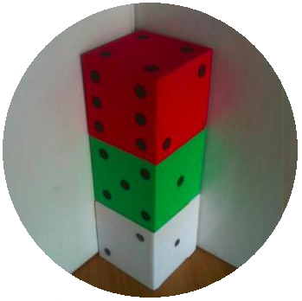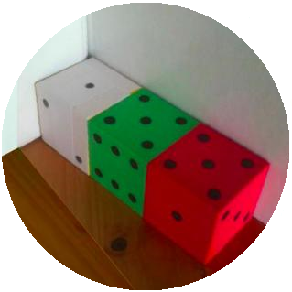
Three dice are sitting in the corner with the simple rule that where two faces touch they must be the same numbers.
So, in the first picture above there are 3s at the bottom of the red dice and on the top of the middle green and there are 4s on the bottom of the green dice and the top of the white dice. The numbers on the seven faces that can be seen are then added and make 21.
In the second picture above there are 4s at the left of the red dice and on the right of the green dice and there are 3s on the left of the green dice and the right of the white dice. The numbers on the seven faces that can be seen are then added and make 23.
Use your own dice (you could use two or three or more...)
What total have you made?
Can you make a different one?
How many different ones can you make?
Now for a challenge - arrange dice (using at least 2 and up to as many as you like) in a line in the corner, so that the faces you can see add up to 18 in as many ways as possible.
Each line of dice must be along or up a wall (or two walls). A line going up is counted the same as a line going along. Remember the dice must touch face to face and have the same numbers touching. The dice must be all in one line, so this arrangement below is not allowed:

